The newly elected President and Vice President of the Nassau County Chapter of the Military Officers Association of America (MOAA), retired Navy Captains Mike Doran and Tony LaVecchia, participated in the MOAA Florida Council of Chapters (FCoC) Leadership Seminar in Orlando, FL 5 -7 January. The seminar provided attendees with organizational updates, training, and legislative affairs information from MOAA national staff members. Thirty-one (31) of the thirty-nine (39) Florida MOAA Chapters were in attendance as well as the national MOAA Board Chairman, retired Air Force General Gary North and the Florida Council of Chapters President, retired Navy Commander Pat Kleuver.

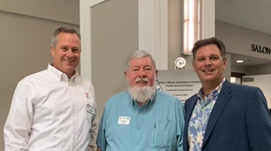

Photo: Mike Doran, Pat Kleuver, Tony LaVecchia

